Introduction:

The following application is designed for Internet of Things.

The 3 phases in this project are:

1. Sensing the information using Arduino (Embedded System)
2. Sending that information to Computer. Let’s say if you have multiple sensors, you can send all the information to computer and processing can happen in computer
3. “Response” taken from the step 2 is fed back to the Arduino. Response is measured based by processing the information of different sensors. So many ways, you can come up with the decision based on the data.
   1. Let’s say if you have sensors data in which you have time series data of 5 sensors, you can get the standard correlation coefficients among different sensors. You can use pearson correlation, spearman correlation and
   2. You can use a variant like Fuzzy Logic.
   3. You can use Granger casuality.

Implementation:

Please find the implementation details for different response systems below:

**a and b Correlation and Fuzzy logic:**

**Experiment 1:**

In arduino, directly we can check for the value of the analog input and if the value is less, then we can turn the light in whatever fashion.

No serial communication is required for this kind of alert system.



When any one of the sensors are not working, it triggers the led and you can consider it as a alert system which is very fast as it is getting processed directly on the Arduino board.

This can be treated as the similar concept of fire alarms.

**Experiment 2:**

Let’s say if the sensor’s data is being processed on a centralized system where you can process multiple microcontroller’s data. You need to perform the interrupt of serial communication. How can you perform the serial communication in both ways is the crux of the project as the microcontroller is continuously printing on the serial port.

Right now, the steps are being followed as below:

1. Micro controller prints the sensor values on to the serial port
2. Computer processes those values and writes on serial port only if the value is below/above a threshold based on the purpose.
3. Microcontroller receives that signal and blinks the led
4. Computer doesn’t know whether the microcontroller receives the signal or not. So, it’s better to send an acknowledgment i.e “yes” back to the computer from the serial port.
5. Computer reads the serial port and then checks the received value with “yes” and then prints out the communication is proper.



To run these two experiments, please use the following files:

**For exp1:**

Only Arduino program is required.

Internship\Granger Causality\Arduino\experiment1_with_no_serial_communication_using_Arduino_processing

**For exp2:**

Please use the Arduino program below for sending and receiving the information to and from the computer.

Internship\Granger Causality\Arduino\experiment2_serial_establishment

Please use the python notebook for establishing the serial communication, sending the information based on the correlation coefficients.

Internship\Granger Causality\Python notebook\Sensing_Correlation_Fuzzy.ipynb

Hard-encoded fuzzy logic is also implemented in the above note book and the detail description is given.

A close up of a logo

Description generated with high confidence

**c) Granger casuality :**

Please go through Dantong Yu paper.

Please go through the below notebook for the Granger casuality and getting the correlation coefficients.

Internship\Granger Causality\Python notebook\Granger_Causal_Coefficients_Yeast_data.ipynb If you wish to send this information to Arduino, you can use the previous notebook.

Granger casuality on large time series steps is given below:

Internship\Granger Causality\Python notebook\Sensor_Granger_Causal_Coefficients.ipynb

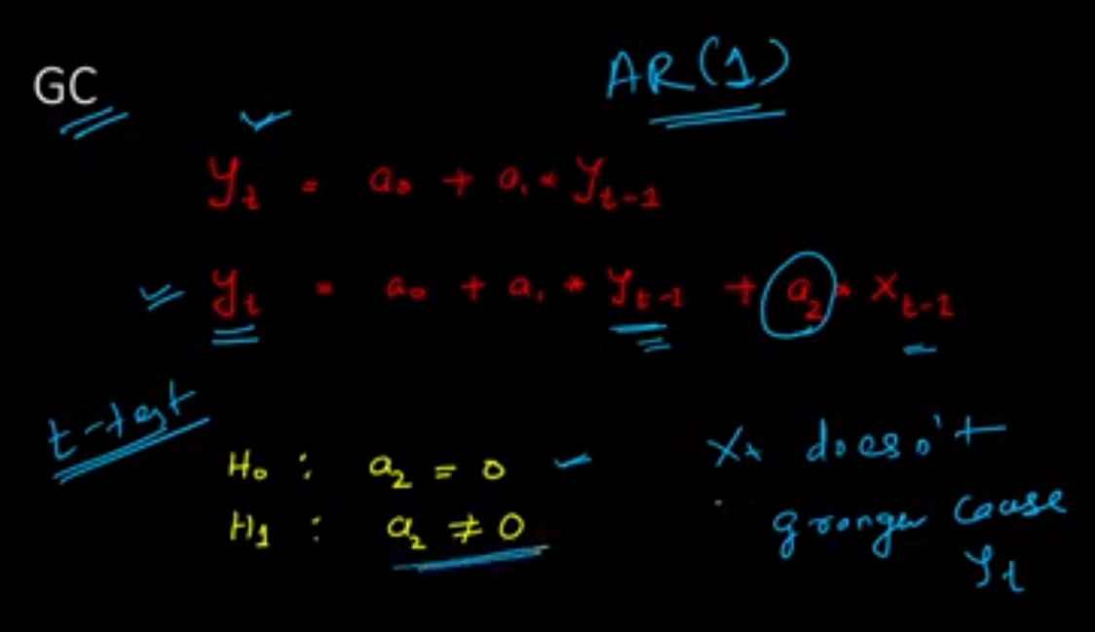A picture containing text, whiteboard

Description generated with very high confidenceA close up of text on a white background

Description generated with very high confidenceA close up of text on a whiteboard

Description generated with high confidence